**EXPERIMENT 2:**

DATE: 01.03.24

2.Write the python program to solve 8-Queen problem

**AIM:**

The aim is to solve the 8queen problem using python program.

**PROGRAM:**

def is_safe(board, row, col):

for i in range(col):

if board[row][i] == 1:

return False

for i, j in zip(range(row, -1, -1), range(col, -1, -1)):

if board[i][j] == 1:

return False

for i, j in zip(range(row, len(board)), range(col, -1, -1)):

if board[i][j] == 1:

return False

return True

def solve_n_queens(board, col):

if col >= len(board):

return True

for i in range(len(board)):

if is_safe(board, i, col):

board[i][col] = 1

if solve_n_queens(board, col + 1):

return True

board[i][col] = 0

return False

def print_solution(board):

for row in board:

print(" ".join(map(str, row)))

def n_queens(n):

board = [[0] * n for _ in range(n)]

if solve_n_queens(board, 0):

print_solution(board)

else:

print("No solution exists.")

n_queens(8)

**INPUT:**

Enter the number:

**OUTPUT:**

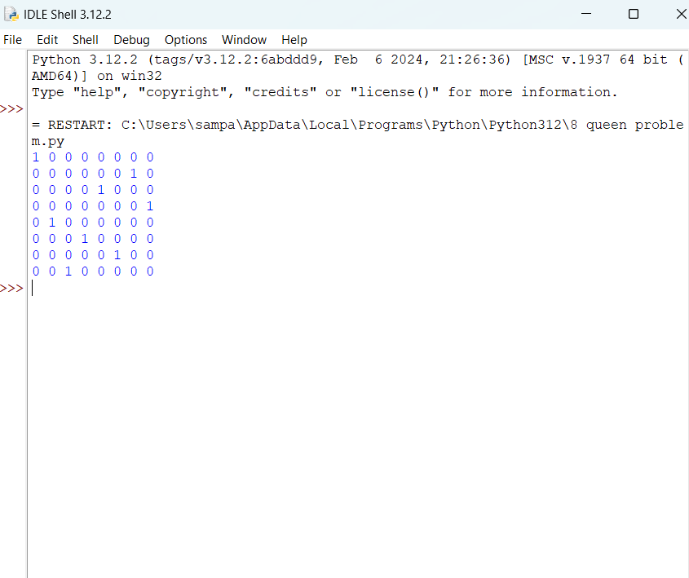

**RESULT:**

The 8queen problem using python program executed successfully.